For unavailable catch:

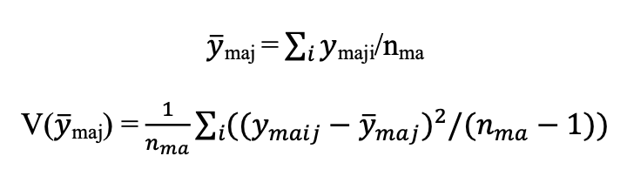

m = mode, a = area, j = species

nma = number of angler trips in mode m and area a

average number of fish per angler trip = sum(# of that fish caught across trips) / number of trips

variance(average number of fish per trip) = 1 / number of trips \* sum over trips[(# of that fish caught in each trip – average number of fish per trip) ^ 2 / (number of trips - 1) ]

For observed catch:

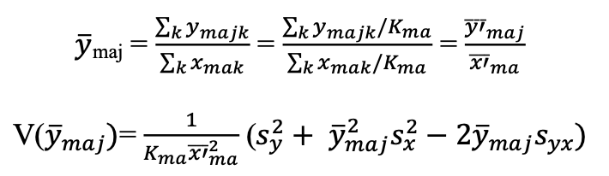

m = mode, a = area, j = species, k = fishing group

Xmak is the number of contributed angler trips in a fishing group

average number of fish per angler trip = average number of that fish caught per fishing group / average number of anglers per fishing group

variance(average number of fish per angler trip) = 1 / [number of fishing groups \* average number of anglers per fishing group ^ 2] \* [variance(number of fish per fishing group) + average number fish per fishing group ^ 2 \* variance(number of anglers per fishing group) – 2 \* average number of fish per fishing group \* covariance(number of fish per fishing group, number of anglers per fishing group)]